**Code assignment Java developer**

**A)**

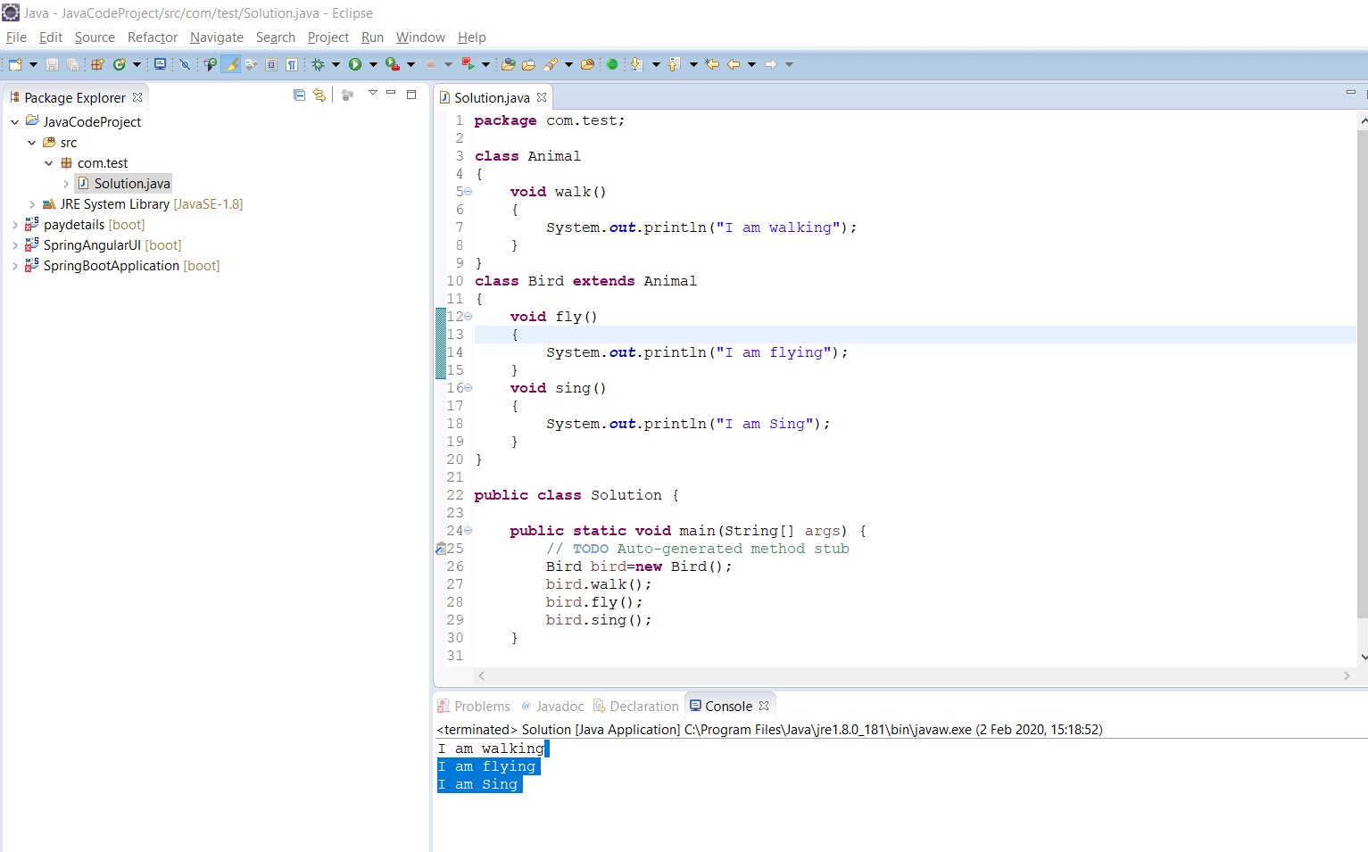

**1) have implemented sing() method in child class**

**1.Usually we are doing unit in IDE and see output in consode**

**2.we are maintain coding standard for each class,class have maximum 700 hundred line only**

**2. Add special kinds of birds**

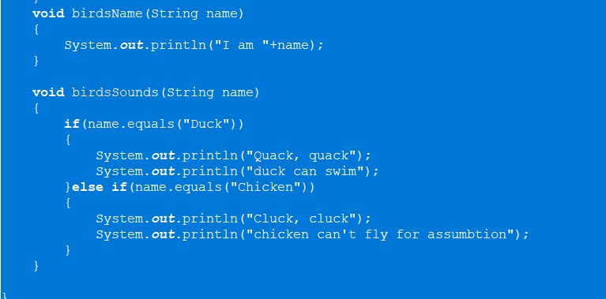

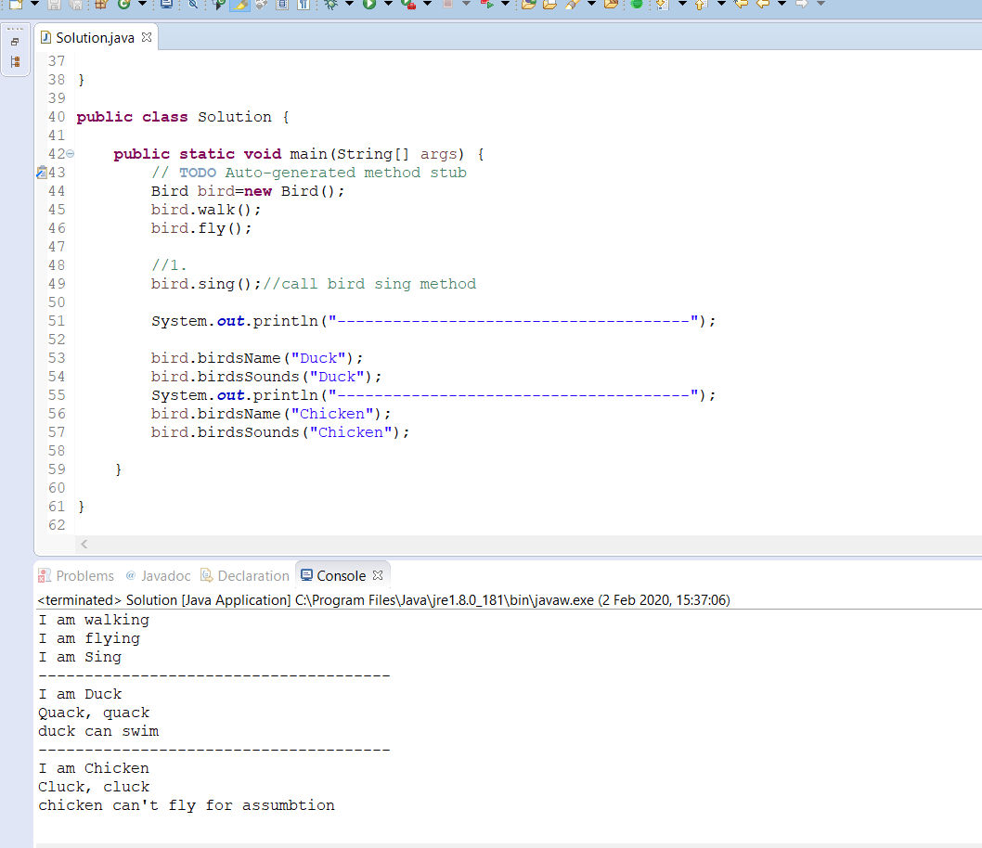

**3.add rooster in parents class**

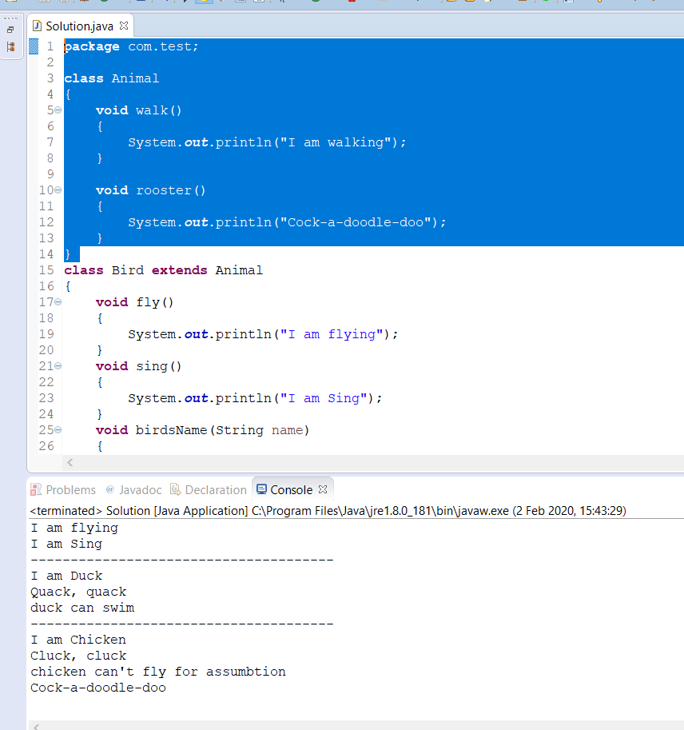

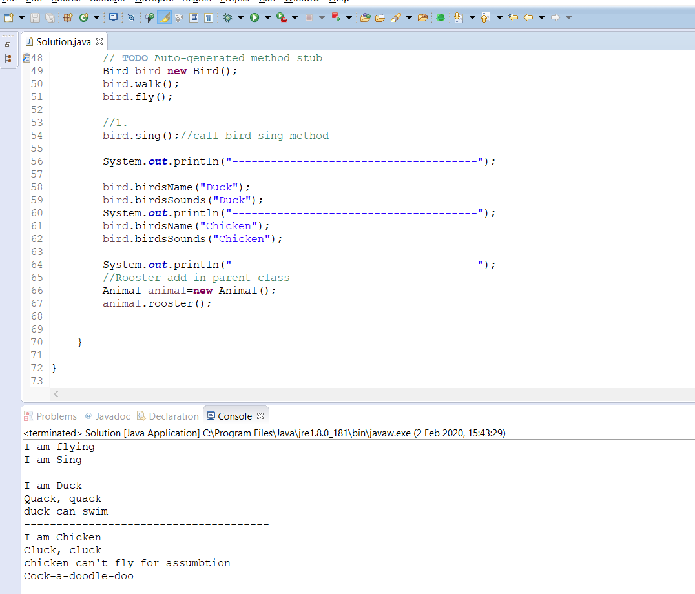

**I have implemented rooster method in parent class**

**4. I have created one parrot method in child class,also created cat and dog method in parent class**

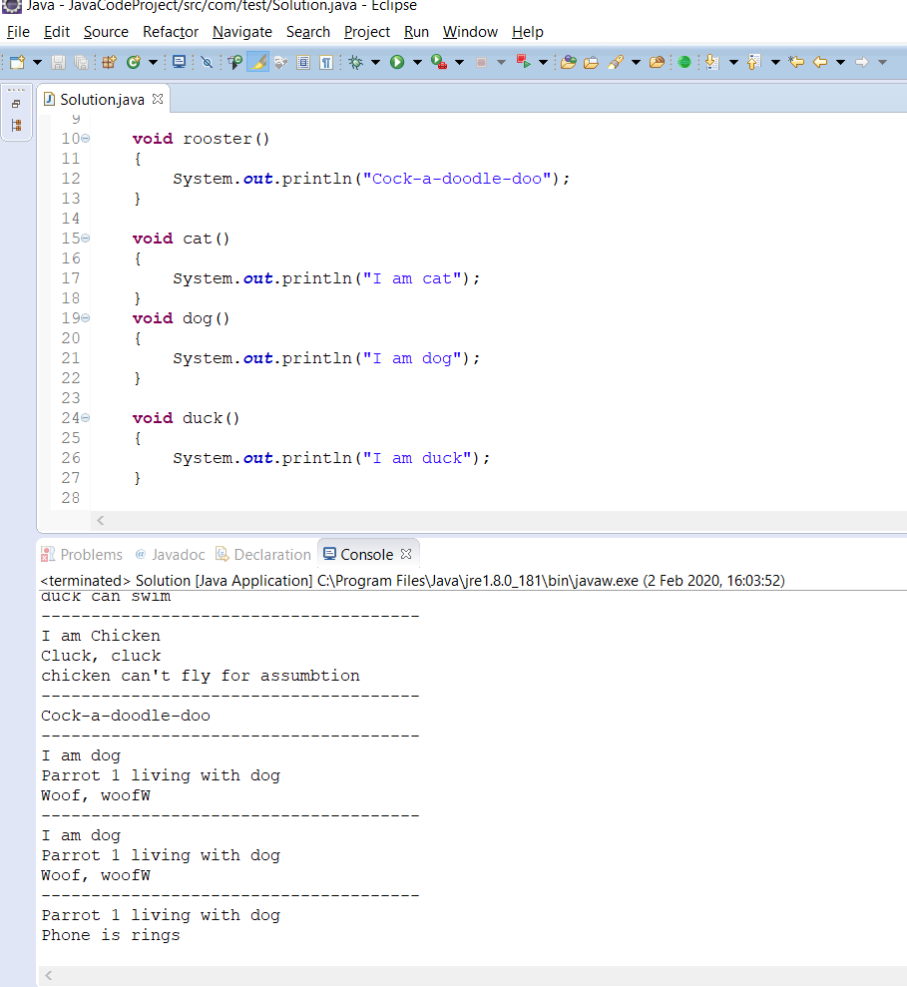

**B.I have add fish model**

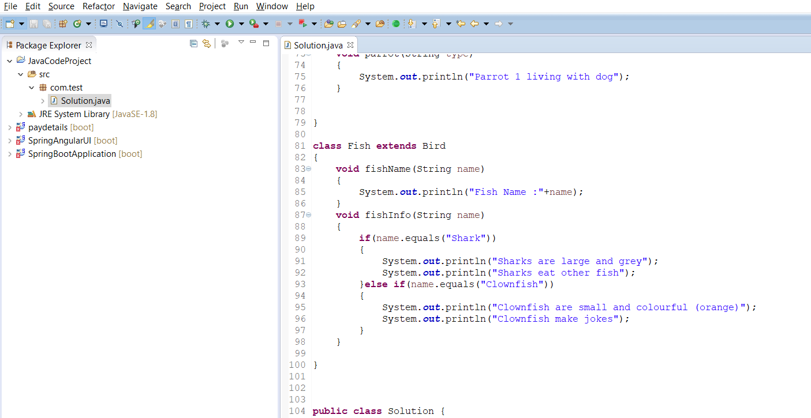

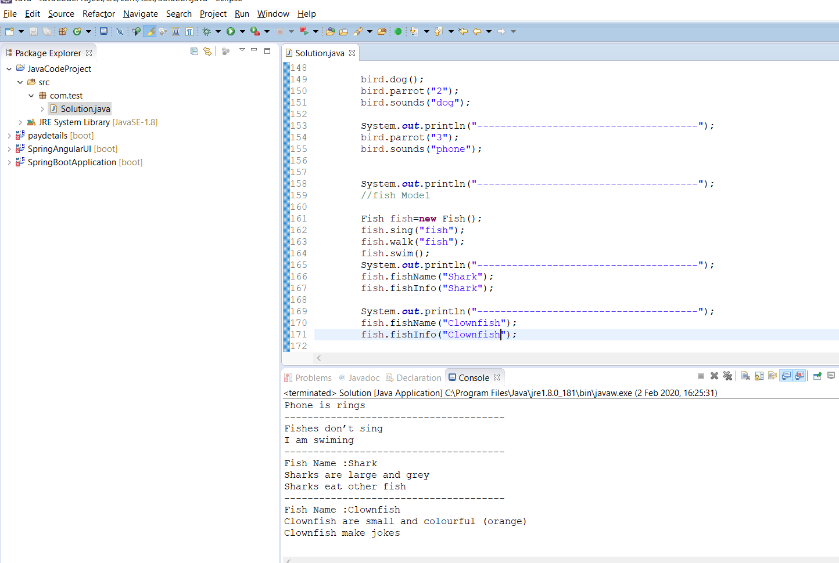

**D.i have implemented butterfly model in bird class**

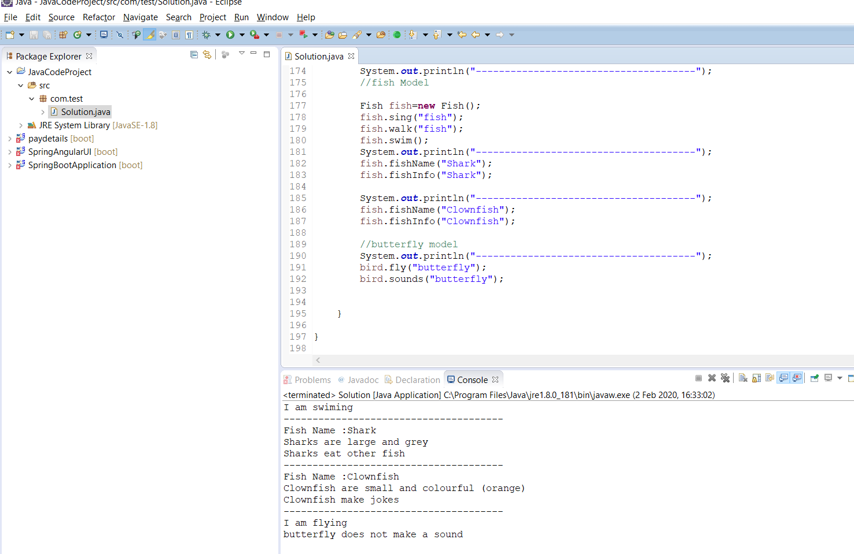

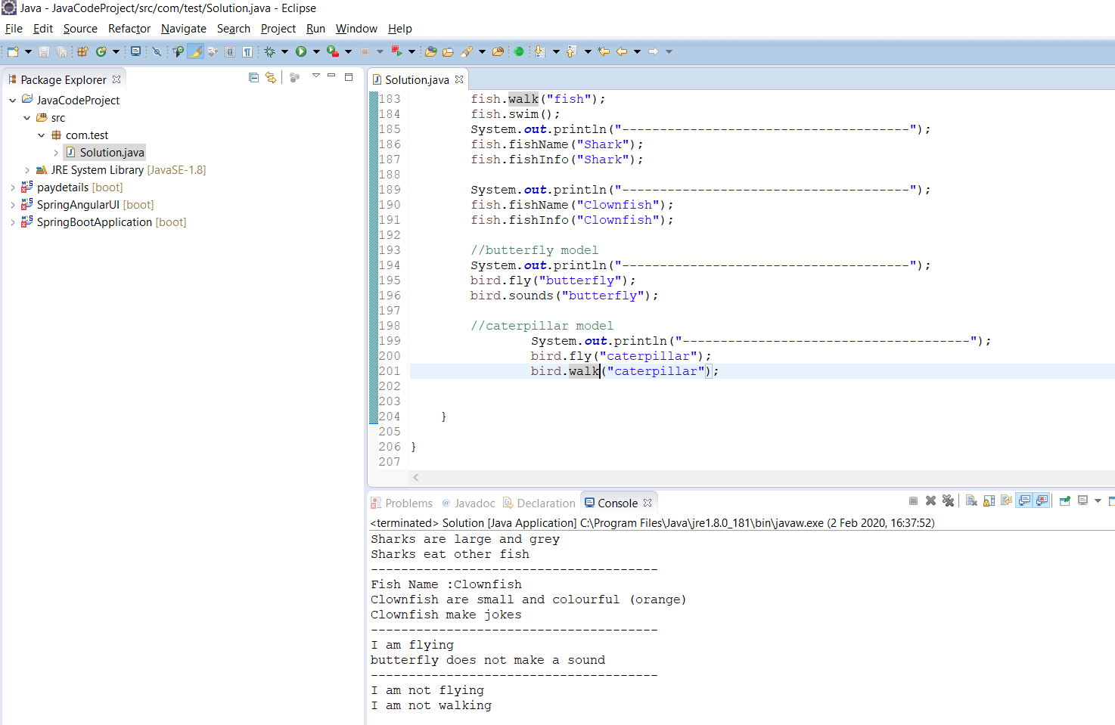

**D.**

**package com.test;**

**class Animal**

**{**

**void walk(String model)**

**{**

**if(model.equals("fish"))**

**{**

**System.out.println("I am not walking");**

**}else**

**if(model.equals("caterpillar"))**

**{**

**System.out.println("I am not walking");**

**}else**

**{**

**System.out.println("I am walking");**

**}**

**}**

**void swim()**

**{**

**System.out.println("I am swiming");**

**}**

**void rooster()**

**{**

**System.out.println("Cock-a-doodle-doo");**

**}**

**void cat()**

**{**

**System.out.println("I am cat");**

**}**

**void dog()**

**{**

**System.out.println("I am dog");**

**}**

**void duck()**

**{**

**System.out.println("I am duck");**

**}**

**}**

**class Bird extends Animal**

**{**

**void fly(String model)**

**{**

**if(model.equals("butterfly"))**

**{**

**System.out.println("I am flying");**

**}else if(model.equals("bird"))**

**{**

**System.out.println("I am flying");**

**}else**

**{**

**System.out.println("I am not flying");**

**}**

**}**

**void sing(String model)**

**{**

**if(model.equals("fish"))**

**{**

**System.out.println("Fishes don’t sing");**

**}else**

**{**

**System.out.println("I am Sing");**

**}**

**}**

**void birdsName(String name)**

**{**

**System.out.println("I am "+name);**

**}**

**void sounds(String name)**

**{**

**if(name.equals("Duck"))**

**{**

**System.out.println("Quack, quack");**

**System.out.println("duck can swim");**

**}else if(name.equals("Chicken"))**

**{**

**System.out.println("Cluck, cluck");**

**System.out.println("chicken can't fly for assumbtion");**

**}else if(name.equals("dog"))**

**{**

**System.out.println("Woof, woofW");**

**}else if(name.equals("cat"))**

**{**

**System.out.println("Meow");**

**}**

**else if(name.equals("phone"))**

**{**

**System.out.println("Phone is rings");**

**}**

**else if(name.equals("butterfly"))**

**{**

**System.out.println("butterfly does not make a sound");**

**}**

**}**

**void parrot(String type)**

**{**

**System.out.println("Parrot 1 living with dog");**

**}**

**}**

**class Fish extends Bird**

**{**

**void fishName(String name)**

**{**

**System.out.println("Fish Name :"+name);**

**}**

**void fishInfo(String name)**

**{**

**if(name.equals("Shark"))**

**{**

**System.out.println("Sharks are large and grey");**

**System.out.println("Sharks eat other fish");**

**}else if(name.equals("Clownfish"))**

**{**

**System.out.println("Clownfish are small and colourful (orange)");**

**System.out.println("Clownfish make jokes");**

**}**

**}**

**}**

**class Duck extends Bird**

**{**

**}**

**class Chicken extends Bird**

**{**

**}**

**class Rooster extends Bird**

**{**

**}**

**class Parrot extends Bird**

**{**

**}**

**class Shark extends Fish**

**{**

**}**

**class ClownFish extends Fish**

**{**

**}**

**class Dolhpin extends Fish**

**{**

**}**

**class Frog extends Animal**

**{**

**}**

**class Dog extends Animal**

**{**

**}**

**class Butterfly extends Bird**

**{**

**}**

**class Cat extends Animal**

**{**

**}**

**public class Solution {**

**public static void main(String[] args) {**

**// TODO Auto-generated method stub**

**Bird bird=new Bird();**

**bird.walk("animal");**

**bird.fly("bird");**

**//1.**

**bird.sing("bird");//call bird sing method**

**System.out.println("--------------------------------------");**

**bird.birdsName("Duck");**

**bird.sounds("Duck");**

**System.out.println("--------------------------------------");**

**bird.birdsName("Chicken");**

**bird.sounds("Chicken");**

**System.out.println("--------------------------------------");**

**//Rooster add in parent class**

**Animal animal=new Animal();**

**animal.rooster();**

**System.out.println("--------------------------------------");**

**bird.dog();**

**bird.parrot("1");**

**bird.sounds("dog");**

**System.out.println("--------------------------------------");**

**bird.dog();**

**bird.parrot("2");**

**bird.sounds("dog");**

**System.out.println("--------------------------------------");**

**bird.parrot("3");**

**bird.sounds("phone");**

**System.out.println("--------------------------------------");**

**//fish Model**

**Fish fish=new Fish();**

**fish.sing("fish");**

**fish.walk("fish");**

**fish.swim();**

**System.out.println("--------------------------------------");**

**fish.fishName("Shark");**

**fish.fishInfo("Shark");**

**System.out.println("--------------------------------------");**

**fish.fishName("Clownfish");**

**fish.fishInfo("Clownfish");**

**//butterfly model**

**System.out.println("--------------------------------------");**

**bird.fly("butterfly");**

**bird.sounds("butterfly");**

**//caterpillar model**

**System.out.println("--------------------------------------");**

**bird.fly("caterpillar");**

**bird.walk("caterpillar");**

**Animal[] obj=new Animal[]**

**{**

**new Bird(),**

**new Duck(),**

**new Chicken(),**

**new Rooster(),**

**new Parrot(),**

**new Fish(),**

**new Shark(),**

**new ClownFish(),**

**new Dolhpin(),**

**new Frog(),**

**new Dog(),**

**new Butterfly(),**

**new Cat()**

**};**

**System.out.println("No Of Animals : "+obj.length);**

**}**

**}**

**Console :**

**I am walking**

**I am flying**

**I am Sing**

**--------------------------------------**

**I am Duck**

**Quack, quack**

**duck can swim**

**--------------------------------------**

**I am Chicken**

**Cluck, cluck**

**chicken can't fly for assumbtion**

**--------------------------------------**

**Cock-a-doodle-doo**

**--------------------------------------**

**I am dog**

**Parrot 1 living with dog**

**Woof, woofW**

**--------------------------------------**

**I am dog**

**Parrot 1 living with dog**

**Woof, woofW**

**--------------------------------------**

**Parrot 1 living with dog**

**Phone is rings**

**--------------------------------------**

**Fishes don’t sing**

**I am not walking**

**I am swiming**

**--------------------------------------**

**Fish Name :Shark**

**Sharks are large and grey**

**Sharks eat other fish**

**--------------------------------------**

**Fish Name :Clownfish**

**Clownfish are small and colourful (orange)**

**Clownfish make jokes**

**--------------------------------------**

**I am flying**

**butterfly does not make a sound**

**--------------------------------------**

**I am not flying**

**I am not walking**

**No Of Animals13**